Selected Excel Text Functions

CONCAT
The CONCAT function combines the text from multiple ranges and/or strings, but it doesn’t provide delimiter (i.e., a comma, space, semicolon, quotes, braces or other character(s) used to separate text strings) or IgnoreEmpty arguments.
The CONCAT function replaces the CONCATENATE function. However, the CONCATENATE function will remain available for earlier versions of Excel.

SYNTAX
CONCAT(text1, [text2],..)
text1 Required. Text item to be joined. A string, or array of strings, such as a range of cells.
[text2,…] Required. Additional text items to be joined. There can be a maximum of 253 text arguments for the text items. Each can be a string, or array of strings, such as a range of cells.
Notes:
- To include delimiters (such as spacing or ampersands (&)) between the text you want to combine, and to remove empty arguments you don’t want to appear in the combined text result, you can use the TEXTJOIN function.
- If the resulting string exceeds 32767 characters (cell limit), CONCAT returns the #VALUE! Error.

EXAMPLES
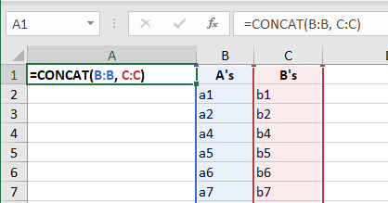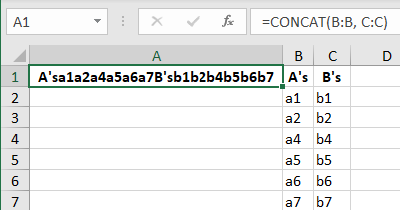
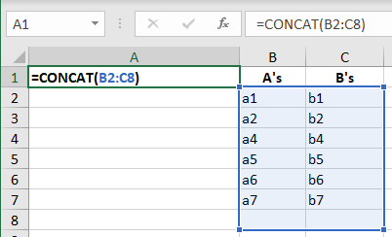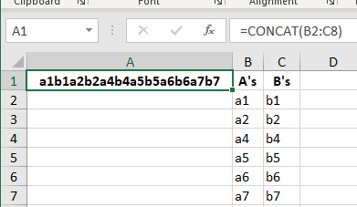
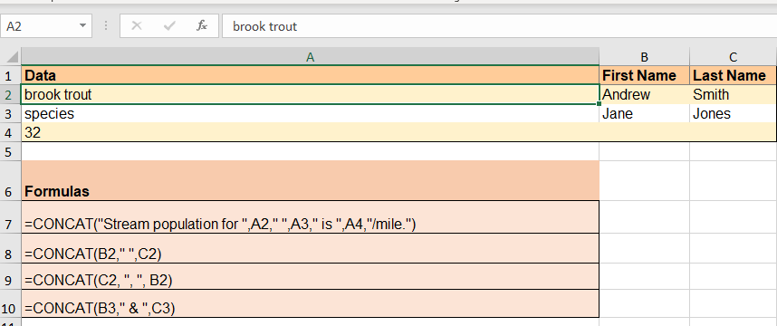
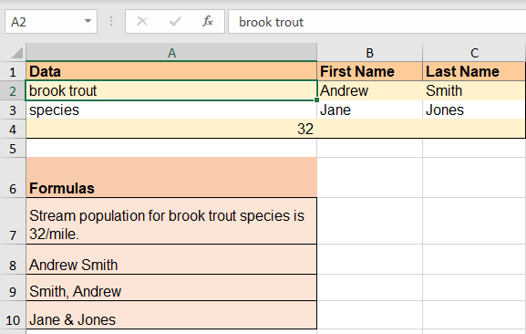

TEXTJOIN
The TEXTJOIN function combines the text from multiple ranges and/or strings, and includes a delimiter you specify between each text value that will be combined. If the delimiter is an empty text string, this function will effectively concatenate the ranges.

SYNTAX

Argument | Description
delimiter  (required) | A text string, either empty, or one or more characters enclosed by double quotes, or a reference to a valid text string. If a number is supplied, it will be treated as text.
ignore_empty  (required) | If TRUE, ignores empty cells.
text1  (required) | Text item to be joined. A text string, or array of strings, such as a range of cells.
[text2, ...]  (optional) | Additional text items to be joined. There can be a maximum of 252 text arguments for the text items, including text1. Each can be a text string, or array of strings, such as a range of cells.

Examples

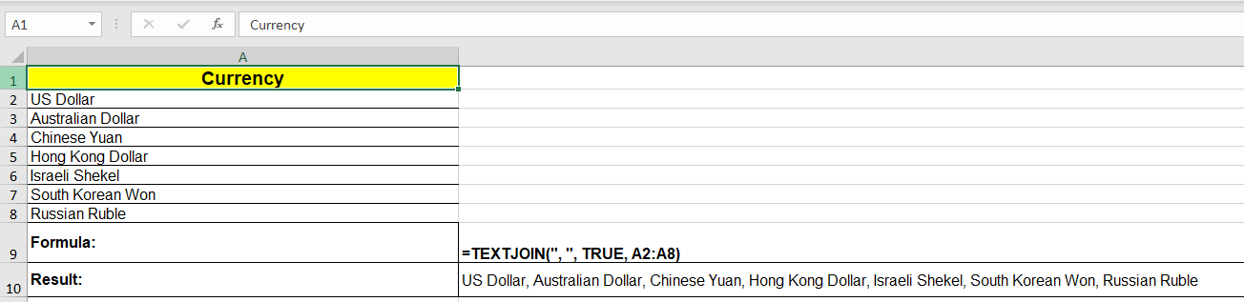
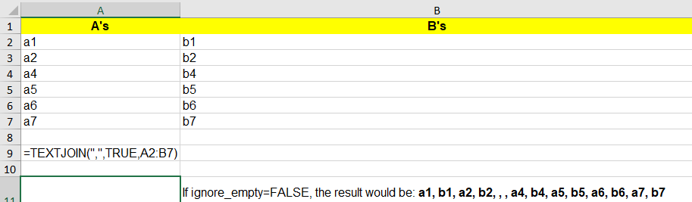
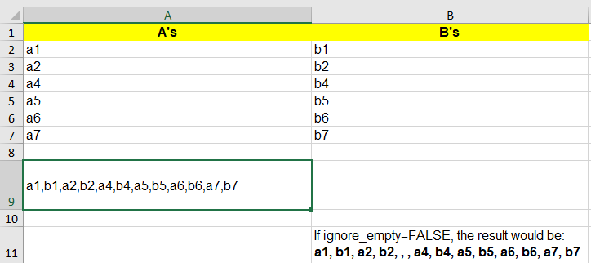
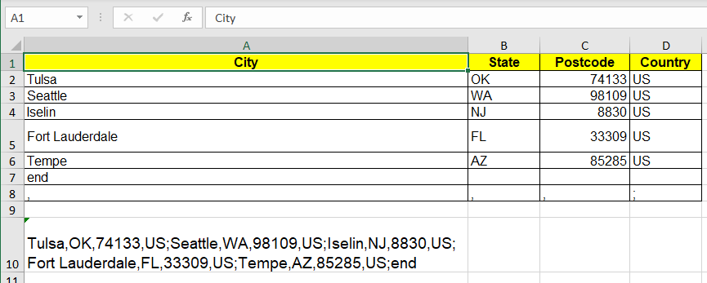
Formula in A10 used to retrieve above results:
=TEXTJOIN(A8:D8,TRUE,A2:D7)

REPLACE

Description
REPLACE replaces part of a text string, based on the number of characters you specify, with a different text string.

SYNTAX
REPLACE(old_text,start_num,num_chars,new_text)
Old_text Required. Text in which you want to replace some characters.
Start_num Required. The position of the character in old_text that you want to replace with new_text.
Num_chars Required. The number of characters in old_text that you want REPLACE to replace with new_text.
New_text Requred. The text that will replace characters in old_text.

EXAMPLES
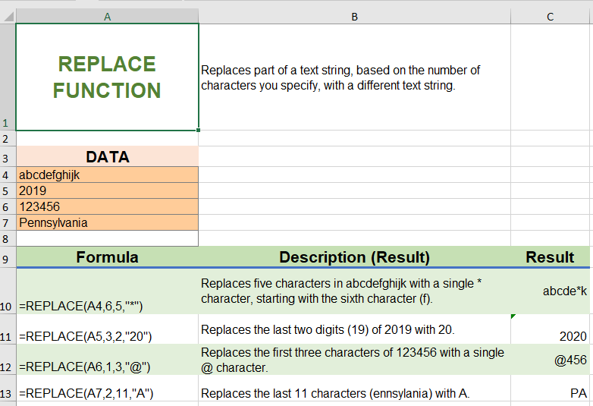

REFERENCES
Microsoft. 2020. “REPLACE, EPLACEB Functions.”https://support.microsoft.com/enus/office/replace-replaceb-functions-8d799074-2425-4a8a-84bc-82472868878a (accessed 25 June 2020).
Microsoft. 2020. "Text Functions (Reference)." https://support.microsoft.com/en-us/office/text-functions-reference-cccd86ad-547d-4ea9-a065-7bb697c2a56e (accessed 25, June 2020).

Microsoft. 2020. “TEXTJOIN Function.” https://support.microsoft.com/en-us/office/textjoin-function-357b449a-ec91-49d0-80c3-0e8fc845691c (accessed 25, June 2020).

Filename: Selected_Excel_Text_Functions.docx. Created 25 June 2020 by Marsha Ann Tate, Ph.D.
marsha@mtateresearch.com. Additional Excel supplemental resources available at https://mtateresearch.com/computer_courses_supplemental_resources

